WASTE HEAT RECOVERY SYSTEM FOR INDUSTRIAL FURNACE
A dissertation
Submitted in partial fulfilment of the requirement for the award of Degree of
MASTER OF TECHNOLOGY

IN
THERMAL ENGINEERING

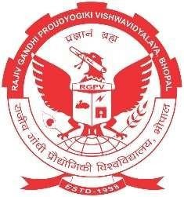
Submitted to
Rajiv Gandhi Proudyogiki Vishwavidhyalaya Bhopal (M.P.) Submitted By:
Gyaneshwar 0126ME21MT05
Under the Guidance of Ms. Shikha Bhatt
(Assistant Professor, M.E. Department) Department of Mechanical Engineering
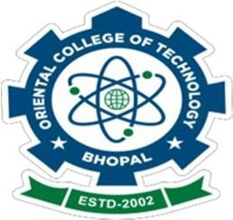
ORIENTAL COLLEGE OF TECHNOLOGY, BHOPAL
Approved by AICTE, New Delhi & Govt. of M.P.
Affiliated to Rajiv Gandhi Proudyogiki Vishwavidhyalaya, Bhopal (M.P.) Session 2021-23


ORIENTAL COLLEGE OF TECHNOLOGY, BHOPAL
Approved by AICTE New Delhi & Govt. of M.P.
Affiliated to Rajiv Gandhi Proudyogiki Vishwavidhyalaya, Bhopal (M.P.)

BONAFIDE CERTIFICATE

This is to certify that the thesis entitled “Waste Heat Recovery System for Industrial Furnace” being submitted by Gyaneshwar in partial fulfilment of the requirement for the award of M. Tech. Degree in Thermal Engineering to Oriental College of Technology, Bhopal (M.P.) is a record of bonafide work done by him under our guidance.

Date:
Place: Bhopal

SUPERVISED BY:
Ms. Shikha Bhatt SUPERVISOR
Department of Mechanical Engineering Oriental College of Technology, Bhopal

Dr. Rajiv Varshney Dr. K.K. Dwivedi (Associate Professor and HOD) Director
Mechanical Engineering OCT, Bhopal
OCT, Bhopal

ORIENTAL COLLEGE OF TECHNOLOGY, BHOPAL
Approved by AICTE New Delhi & Govt. of M.P.
Affiliated to Rajiv Gandhi Proudyogiki Vishwavidhyalaya, Bhopal (M.P.)

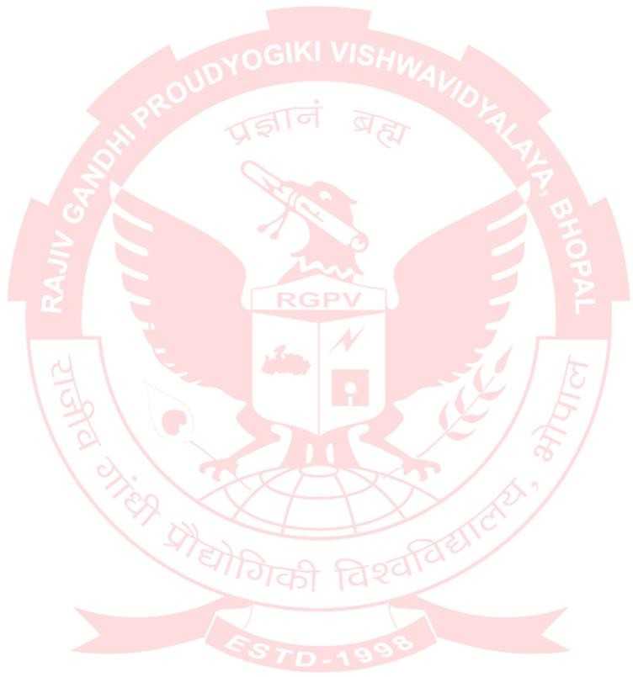
APPROVAL CERTIFICATE

The dissertation entitled “Waste Heat Recovery System for Industrial Furnace” being submitted by “Gyaneshwar (0126ME21MT05)” has been examined by us and is hereby approved for the award of degree Master of Technology in ThermalEngineering for which it has been submitted. It is understood that by this approval the undersigned do not necessarily endorse or approve any statement made, opinion expressed or conclusion drawn therein, but approve the dissertation only for the purpose for which it has been submitted.

INTERNALEXAMINER EXTERNALEXAMINER
(Name & Designation) (Name & Designation) Institute Name:

Date: Date:

ORIENTAL COLLEGE OF TECHNOLOGY, BHOPAL
Approved by AICTE New Delhi & Govt. of M.P.
Affiliated to Rajiv Gandhi Proudyogiki Vishwavidhyalaya, Bhopal (M.P.)

CANDIDATE DECLARATION

I Gyaneshwar, student of Master of Technology in Thermal Engineering, Oriental College of Technology, Bhopal (M.P), hereby declare that the work presented in this dissertation entitled “Waste Heat Recovery System for Industrial Furnace” is the outcome of my own work, is bonafide and correct to the bestof my knowledge and this work has been carried out taking care of engineering ethics. The work presented does not infringe any patented work and has not been submitted to any other University or anywhere else for the award of any degreeor any professional diploma.

Gyaneshwar (0126ME21MT05)

ORIENTAL COLLEGE OF TECHNOLOGY, BHOPAL
Approved by AICTE New Delhi & Govt. of M.P.
Affiliated to Rajiv Gandhi Proudyogiki Vishwavidhyalaya, Bhopal (M.P.)

DECLARATION

I hereby declare that the dissertation entitled “Waste Heat Recovery System for Industrial Furnace” is being submitted on the partial fulfilment for the award of the degree of Master of Technology in “Thermal Engineering”. The work has been carried out in the department of “Mechanical Engineering” (Oriental College of Technology, Bhopal) is an authentic record of my own work carried out under the guidance of “Dr. Rajiv Varshney”. I have not submitted the matter embodied in this report for the award of any degree. I also declare that A check for Plagiarism has been carried out on the thesis/project/dissertation is found within the acceptable limit and the report of which is enclosed herewith.

Date: Gyaneshwar
Place: Bhopal (0126ME21MT05)

Guided By: Forwarded By:
Ms. Shikha Bhatt Dr. Rajiv Varshney
Assistant Professor Head of the Department
Department of Mechanical Department of Mechanical
Engineering, OCT, Bhopal Engineering, OCT, Bhopal

Approved By
Dr. K.K. Dwivedi Director, OCT Bhopal

ORIENTAL COLLEGE OF TECHNOLOGY, BHOPAL
Approved by AICTE New Delhi & Govt. of M.P.
Affiliated to Rajiv Gandhi Proudyogiki Vishwavidhyalaya, Bhopal (M.P.)
PLAGIARISM CERTIFICATE

The Content of this dissertation work has been checked for plagiarism with the help of Plagiarism Checker X software.

This is to certify that no portion of the un-referred content is found to have plagiarism.

Gyaneshwar (0126ME21MT05)

ORIENTAL COLLEGE OF TECHNOLOGY, BHOPAL
Approved by AICTE New Delhi & Govt. of M.P.
Affiliated to Rajiv Gandhi Proudyogiki Vishwavidhyalaya, Bhopal (M.P.)

ACKNOWLEDGMENT

I am heartily thankful to the Management of Oriental College of Technology for providing me all the facilities and infrastructure to take my work to the final stage. It is the constant supervision, moral support and proper guidance of our respected Director Dr. K.K. Dwivedi, who motivated throughout the work.

I express deep sense of gratitude and respect to my learned guide Dr. Rajiv Varshney, Associate Professor, Department of Mechanical Engineering, during all phases of my work. Without his enthusiasm and encouragement this dissertation would not have been completed. His valuable knowledge and innovative ideas helped me to take the work to the final stage. He has timely suggested actions and procedures to follow for which I am really grateful and thankful to him.

Constant help, moral and financial support of my loving parents motivated me to complete the work. I express my heartily thanks to my all-family members for their co-operation.

I really admire the fond support of my class-mates for their co-operation and constant help. It gives immense pleasure to acknowledge the encouragement and support extended by them. Last but not least I am extremely thankful to all who have directly or indirectly helped me for the completion of my work.

Gyaneshwar (0126ME21MT05)

ORIENTAL COLLEGE OF TECHNOLOGY, BHOPAL
Approved by AICTE New Delhi & Govt. of M.P.
Affiliated to Rajiv Gandhi Proudyogiki Vishwavidhyalaya, Bhopal (M.P.)

ABSTRACT

Industrial furnaces are widely used in sectors such as metallurgy, ceramics, glass manufacturing, and chemical processing, where high-temperature operations are essential. However, these furnaces are also among the most energy-intensive equipment, with a significant portion of the input energy lost as waste heat through flue gases and other thermal losses. This thesis presents a comprehensive study on the development and implementation of a Waste Heat Recovery System (WHRS) designed specifically for industrial furnaces, with the objective of improving overall energy efficiency, reducing fuel consumption, and minimizing environmental impact.
The research begins with a detailed analysis of the thermal characteristics of industrial furnaces, identifying key sources and magnitudes of heat loss. Various waste heat recovery technologies are reviewed, including recuperators, regenerators, economizers, and heat pipe exchangers. Their suitability is evaluated based on factors such as operating temperature range, heat transfer efficiency, material compatibility, and integration feasibility with existing furnace systems.
A prototype WHRS was designed and developed using a high-efficiency shell-and-tube heat exchanger, optimized for recovering heat from exhaust gases to preheat combustion air. Computational simulations were conducted to model heat transfer dynamics and predict system performance under varying operational conditions. The system was then experimentally tested in a controlled industrial setup, and the results demonstrated a significant increase in thermal efficiency—up to 25% improvement—along with a corresponding reduction in fuel usage and carbon dioxide emissions.
In addition to technical performance, the thesis includes an economic analysis that assesses the cost-effectiveness of the WHRS. Parameters such as capital investment, operational savings, maintenance requirements, and payback period are thoroughly examined. The findings indicate that the system offers a favorable return on investment, with a typical payback period of less than two years, making it a viable solution for industries seeking to enhance sustainability and reduce operational costs.
Furthermore, the environmental benefits of implementing WHRS are discussed, highlighting its role in supporting global efforts toward energy conservation and emission reduction. The study concludes with recommendations for future research, including the integration of advanced control systems, use of phase change materials for thermal storage, and adaptation of WHRS for variable-load furnace operations.
Overall, this thesis demonstrates that waste heat recovery is not only a technically feasible and economically beneficial strategy but also a critical component of sustainable industrial energy management.

ORIENTAL COLLEGE OF TECHNOLOGY, BHOPAL
Approved by AICTE New Delhi & Govt. of M.P.
Affiliated to Rajiv Gandhi Proudyogiki Vishwavidhyalaya, Bhopal (M.P.)

TABLE OF CONTENTS
Bonafide certificate | Page No.  I
Approval certificate | II
Candidate declaration | III
Declaration | IV
Plagiarism certificate | V
Acknowledgment | VI
Abstract | IX
Table of contents | X
List of figures | XIII
List of tables | XV
Executive Summary
Introduction and Background
Previous Studies
Findings from Previous Reports
Waste Heat in Major Industry Sectors
Aluminum – Primary Production
Aluminum – Recycling and Secondary Melting
Steel – Integrated Steel Mill
Steel – Mini Mill or EAF Mill
Glass – Fiberglass Manufacturing
Chemicals and Petroleum Refining – Major Operations
Paper – Paper Mill
Food (Snack) Manufacturing
Cement – Dry Process and Shaft Furnaces
Coatings – Vinyl Coating Mill
Typical Waste Heat Streams in Plant Operations
Exhaust Gases or Vapors
Heated Water or Liquid
Heated Products or By-Products
High-Temperature Surfaces
Barriers to Waste Heat Recovery
Barriers by Type of Waste Heat Stream
Barriers by Major Industry
Current Status of Waste Heat Recovery Technologies
Commonly Used Waste Heat Recovery Systems
Emerging or Developing Waste Heat Recovery Technologies
Limitations of Currently Available Technologies
R&D Opportunities
R&D Opportunities for Various Temperature Ranges
R&D Opportunities by Major Industry
R&D Opportunities by Research Category
Report Summary
Appendix A: Waste Heat Recovery Equipment and Systems
Commonly Used Waste Heat Recovery Equipment and Systems
Emerging Waste Heat Recovery Technologies
REFERENCES

ORIENTAL COLLEGE OF TECHNOLOGY, BHOPAL
Approved by AICTE New Delhi & Govt. of M.P.
Affiliated to Rajiv Gandhi Proudyogiki Vishwavidhyalaya, Bhopal (M.P.)

LIST OF FIGURES

S No. | Title | Page  No.
1. | Major Areas of Energy Use in a Manufacturing Plant
2. | Estimates of Energy Losses for Major Energy Use Areas in Manufacturing
3. | Metallic Convection Recuperator Design and Application
4. | Typical Radiation Recuperator
5. | Self-Recuperative Burner Designs (Direct Fired and Radiant Tube Application)
6. | Large Regenerative Heat Recovery System Used in Glass and Steel Industries
7. | Regenerative Burners for Medium to Small Furnaces
8. | Waste Heat Boiler (HRSG) Application for Gas Turbine Exhaust Gases
9. | Typical Heat Wheel Type Waste Heat Recovery Unit
10. | Typical Heat Pipe Used for Waste Heat Recovery
11. | Feedwater Economizer – Typical Unit and Installation on a Boiler
12. | Commonly Used Shell and Tube Type Heat Exchanger for Fluid Heating
13. | Commonly Used Plate Type Heat Exchanger for Fluid (Mostly Liquid) Heating
14. | Heat Recovery for HVAC Application Using Recirculating Liquid
15. | Direct Contact Water Heater Used for Latent Heat Recovery from Flue Gases
16. | Simplified Absorption Cycle Using Heat
17. | Schematic for Electrical Power Generation System Components
18. | Organic Rankine Cycle (ORC) System Components
19. | Organic Rankine Cycle (ORC) System Components and Cost Distribution
20. | Kalina Cycle System Components
21. | Thermo-Electric Generator (TEG) System Components
22. | Convection Heat Transfer Enhancement by Using Dimpled Tubes
23. | Heat Balance (Sankey Diagrams) Showing Energy Savings with Use of Thermochemical Recuperative (TCR) System
24. | Transport Membrane Condenser (TMC) System Components
25. | Super Boiler System Components
26. | Electrical Power Generation System that Uses Supercritical Carbon Dioxide – Echogen System
27. | 250 kW Demonstration Unit – Echogen System
28. | Natural Energy Engine – a Liquid Carbon Dioxide (CO₂) Based Power Generation System

ORIENTAL COLLEGE OF TECHNOLOGY, BHOPAL
Approved by AICTE New Delhi & Govt. of M.P.
Affiliated to Rajiv Gandhi Proudyogiki Vishwavidhyalaya, Bhopal (M.P.)

LIST OF TABLES

S No. | Title | Page  No.
1. | Temperature Range and Characteristics for Industrial Waste Heat Sources
2. | Energy Loss Factors for Major Energy Systems in a Manufacturing Plant
3. | RD&D Opportunities and Barriers Addressed
4. | Waste Streams, Industries of Origin, and Characteristic Temperatures Coded by Color
5. | Matrix of Waste Heat Sources, Recovery Opportunities and Barriers for the Iron and Steel Industry
6. | Matrix of Waste Heat Sources, Recovery Opportunities and Barriers for the Paper Industry
7. | Matrix of Waste Heat Sources, Recovery Opportunities and Barriers for the Cement Industry
8. | Matrix of Waste Heat Sources, Recovery Opportunities and Barriers for the Food (Snack) Manufacturing Industry
9. | Matrix of Waste Heat Sources, Recovery Opportunities and Barriers for the Glass Industry
10. | Matrix of Waste Heat Sources, Recovery Opportunities and Barriers for the Aluminum Industry
11. | Waste Matrix of Waste Heat Sources, Recovery Opportunities and Barriers for the Chemical and Petroleum Refining Industries
12. | Commonly Used Waste Heat Recovery Systems by Temperature Range
13. | Emerging or Developing Waste Heat Recovery Technologies by Temperature Range
14. | Limitations of Currently Available Waste Heat Recovery Technologies, High and Ultra High Temperature Ranges
15. | Limitations of Currently Available Waste Heat Recovery Technologies, Medium Temperature Ranges
16. | Comparison of Low Temperature Electric Power Generation Systems

Key Words- Waste Heat Recovery, Re-Heating Furnaces, Energy Efficiency, Thermal Battery, Flue Gas Heat Recovery, Combustion Air Preheating, Heat Transmission Losses, Energy Conservation, Pollution Mitigation, Greenhouse Gas Emissions,

